Part (iii):

Input:
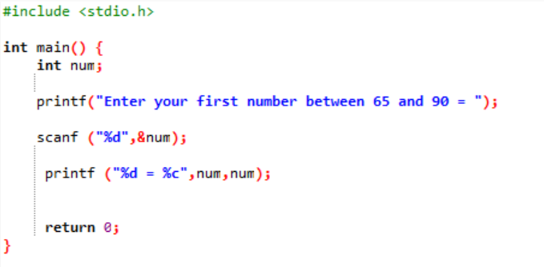

Output:

